Breath First Search:
A
A --> B
A --> C
A --> B --> E
A --> B --> C
A --> C --> G (Goal)
Path to last Goal Node: A --> C --> G (Goal) Cost: 14.0
Nodes expanded: 6

Snapshots of Path:
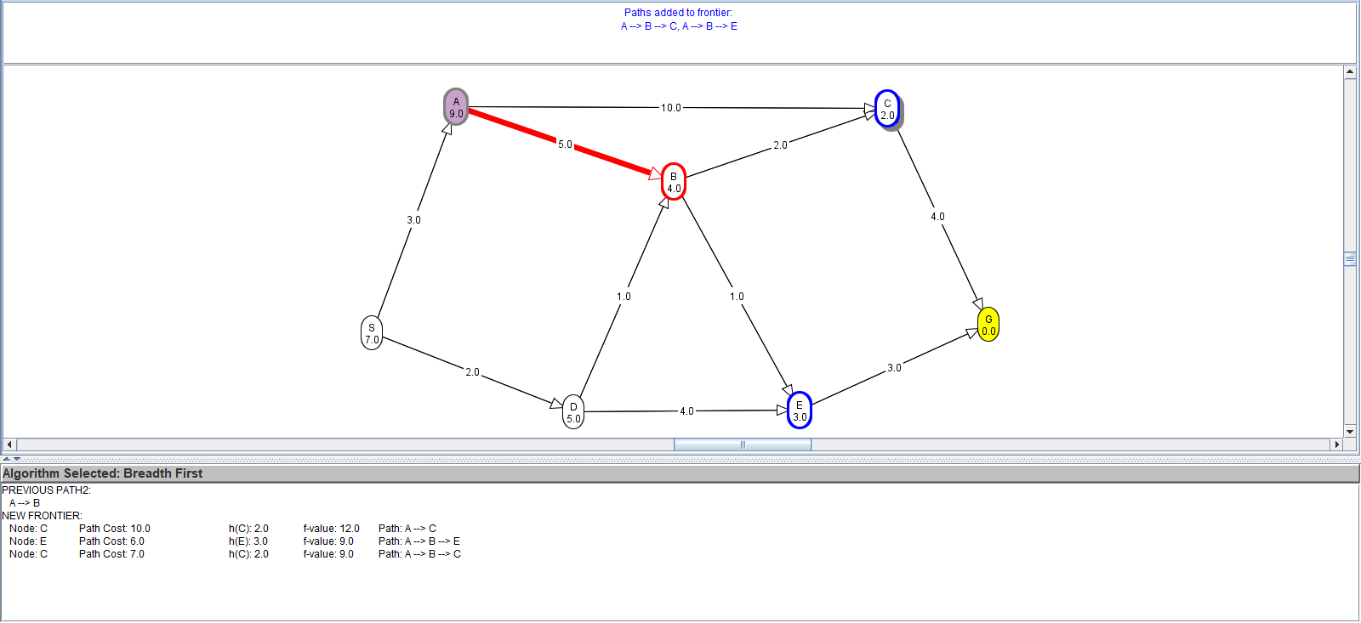
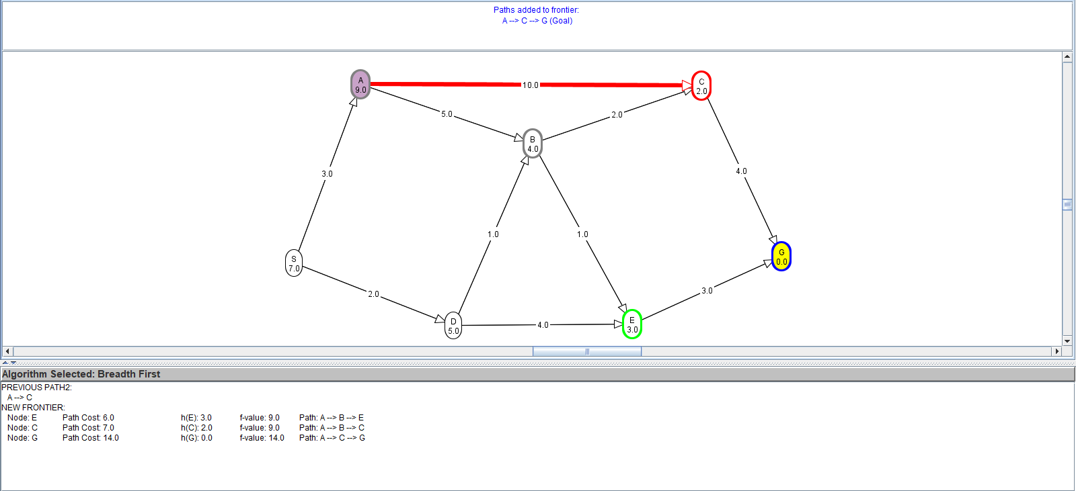

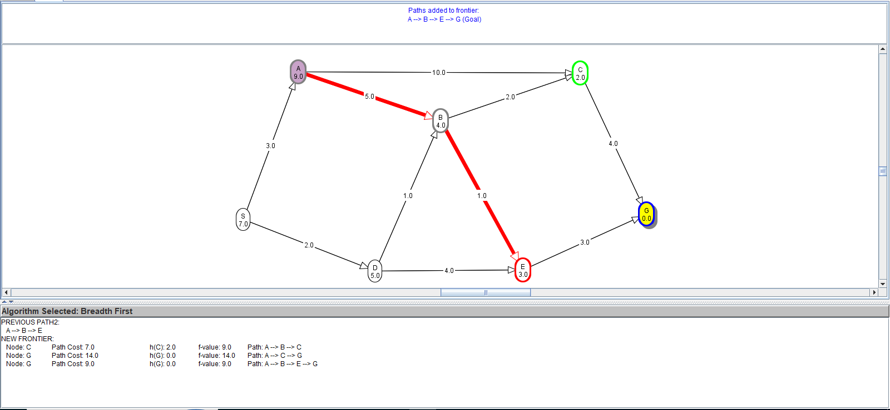
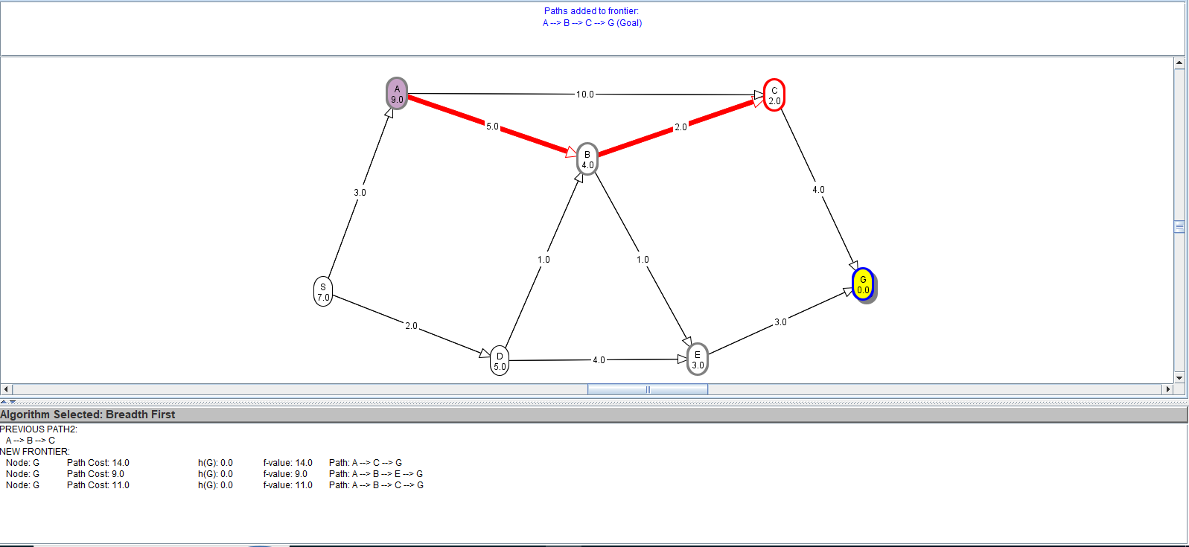
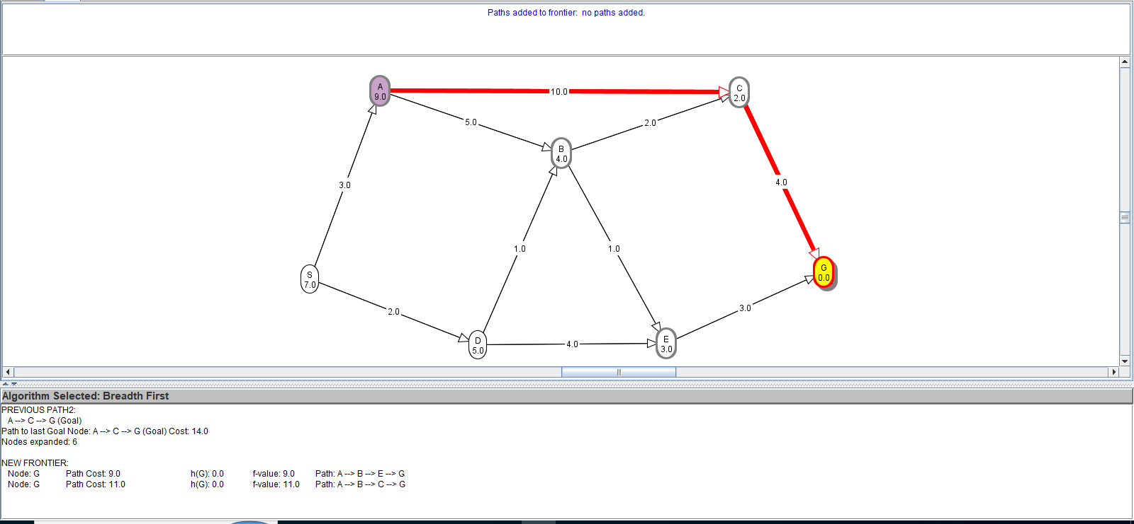

Depth First Search
A
A --> B
A --> B --> E
A --> B --> E --> G (Goal)
Path to last Goal Node: A --> B --> E --> G (Goal) Cost: 9.0
Nodes expanded: 4

Snapshots of Path:
